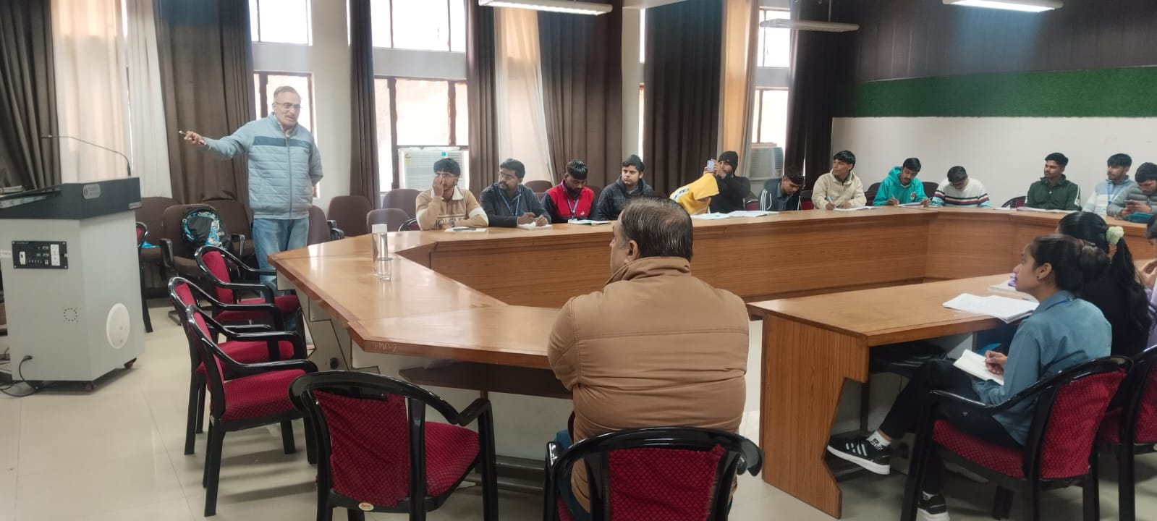
Industry Readiness Training Program by Maruti Suzuki India Ltd. Gurugram at Conference Room of GBN GP Nilokheri on 19.01.2026 for Elect.Engg. 6th sem. Students

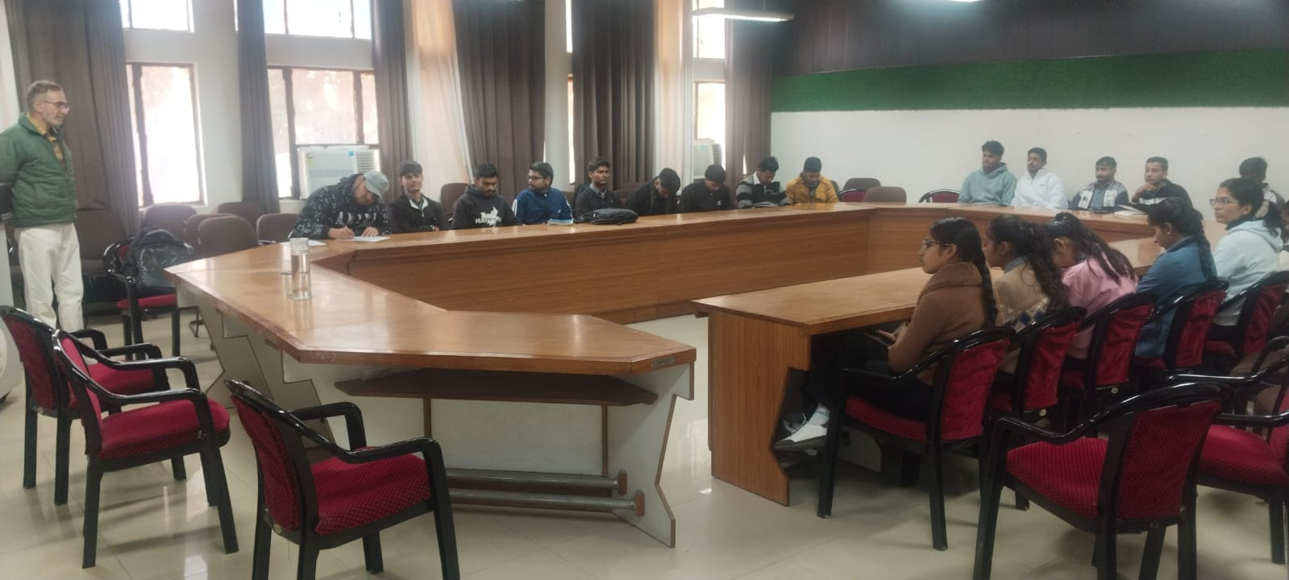
Industry Readiness Training Program by Maruti Suzuki India Ltd. Gurugram at Conference Room of GBN GP Nilokheri on 20.01.2026 for Mech.Engg.Students

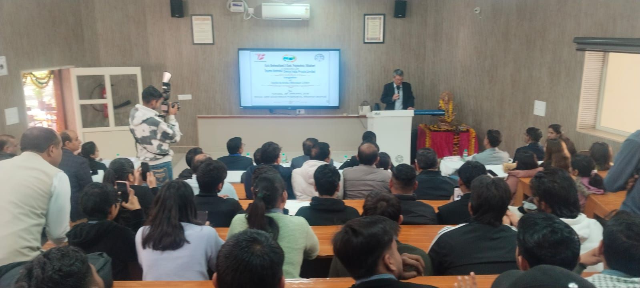
Inauguration of Toyota Boshoku Hitozukuri Centre at GBN GP Nilokheri on 20.01.26 by MD & Team of Toyota Boshoku Device India Pvt Ltd, Bawal under MoU
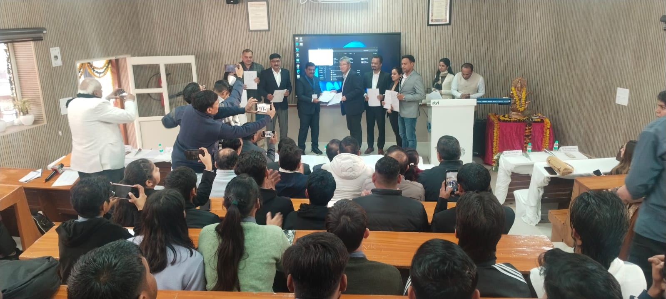
MoU Exchange ceremony between this institute & Toyota Boshoku Device India Pvt Ltd, Bawal on 20.01.26 at this institute
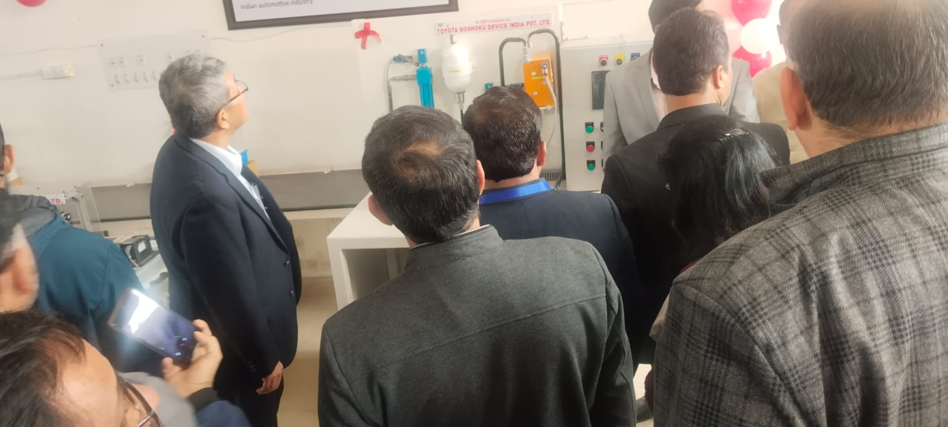
Inauguration of Toyota Boshoku Company Lab Kit at IC Engg. Block at GBN GP Nilokheri on 20.01.26 by MD & Team of Toyota Boshoku Device India Pvt Ltd, Bawal under MoU
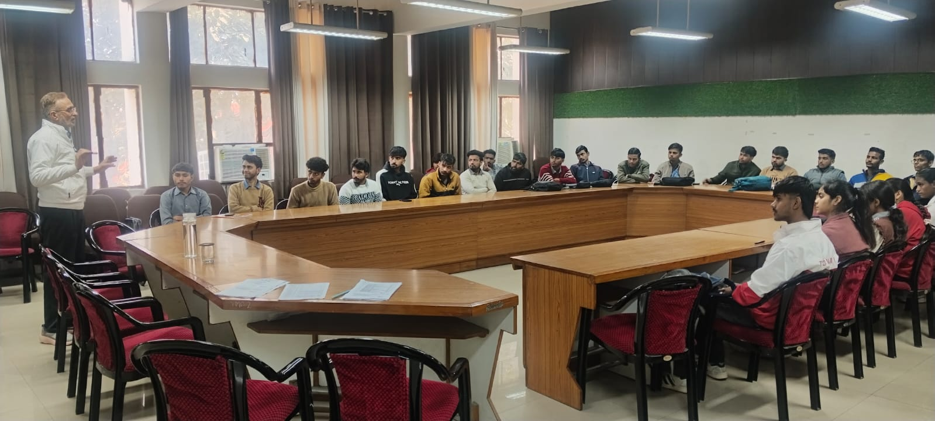
Industry Readiness Training Program by Maruti Suzuki India Ltd. Gurugram at Conference Room of GBN GP Nilokheri on 22.01.2026 for ECE Students

